SEPA Direct Debit Mandate

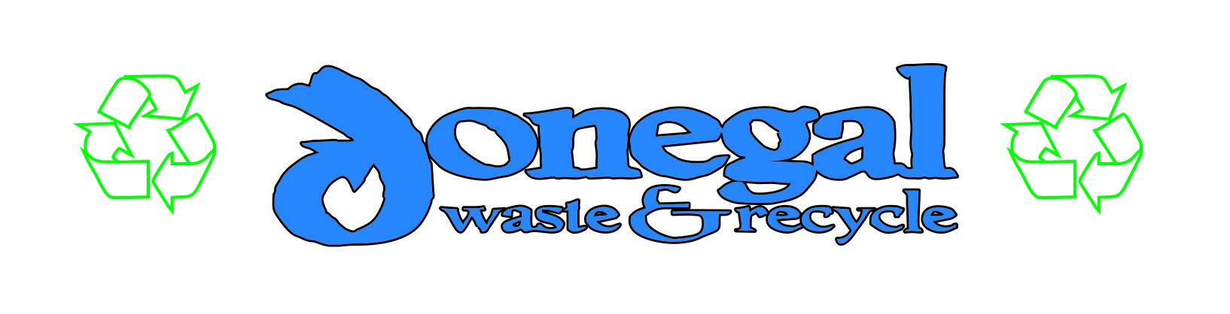

Unique Mandate Reference
Unique Mandate Reference (UMR) – to be completed by Shaun Molloy + Sons

By signing this mandate form, you authorise (A) Shaun Molloy + Sons Limited to send instructions to your bank to debit your account and (B) your bank to debit your account in accordance with the instructions from Shaun Molloy + Sons Limited.
As part of your rights, you are entitled to a refund from your bank under the terms and conditions of your agreement with your bank.
A refund must be claimed within 8 weeks starting from the date on which your account was debited. Your rights are explained in a statement that you can obtain from your bank.

Please complete all the fields marked *
Creditor’s name
 | S | H | A | U | N |  | M | O | L | L | O | Y | + | S | O | N | S |  | L | T | D

Creditor identifier
 | I | E | 8 | 0 | S | D | D | 3 | 6 | 1 | 3 | 7 | 2

Creditor address
 | A | R | D | L | E | N | A | G | H
City
 | D | O | N | E | G | A | L |  | T | O | W | N
Post Code | F | 9 | 4 | X | 6 | P | H
County
 | D | O | N | E | G | A | L

Type of payment *
 | Recurrent payment |  | One-off or payment

Debtor Name *

Debtor Address
City
Eircode
County

Phone

Email

Debtor account number – IBAN *

Debtor bank identifier code – BIC

Date of signature *
 | D | D | M | M | Y | Y

Signature(s)
Please sign here *

Please return this mandate to the Creditor

